Write the three different notations which describes the angles below:

1.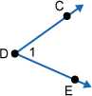

2.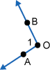

Use the figure below for problems #3 - #6.   Find https://my.westcottcourses.com/images/common/angleNOarc.gif1 and https://my.westcottcourses.com/images/common/angleNOarc.gif2.

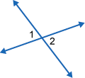

3. https://my.westcottcourses.com/images/common/angleNOarc.gif1 = x + 5   and   https://my.westcottcourses.com/images/common/angleNOarc.gif2 = 3x - 25

4. https://my.westcottcourses.com/images/common/angleNOarc.gif1 = x + 6   and   https://my.westcottcourses.com/images/common/angleNOarc.gif2 = 2x - 12

5. https://my.westcottcourses.com/images/common/angleNOarc.gif1 = 3x + 2   and   https://my.westcottcourses.com/images/common/angleNOarc.gif2 = 2x + 5

6. https://my.westcottcourses.com/images/common/angleNOarc.gif1 = 8x - 2   and   https://my.westcottcourses.com/images/common/angleNOarc.gif2 = 6x + 8

Use the figure below for problems #7 - #10.   Categorize as one of the following: supplementary angles, complementary angles, or vertical angles

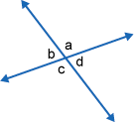

7. Angles a and b.

8. Angles b and d.

9. Angles a and d.

10. Angles b and c.

Use the figure below for problems #11 - #14.   Categorize as one of the following: supplementary angles, complementary angles, or vertical angles.

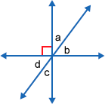

11. Angles a and b.

12. Angles c and d.

13. Angles a and c.

14. Angles b and d.

Find angle a in the following figures:

15.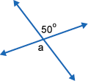

16.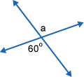

17.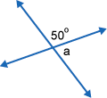

18.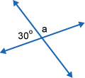

Find x:

19.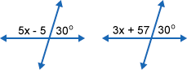

20.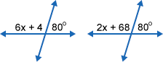

21.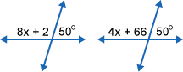

22.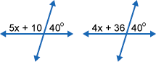

23.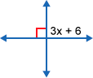

24.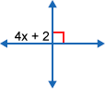

25.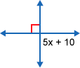

26.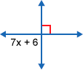

Use the figure below for problems #27 and #28.

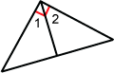

27. If https://my.westcottcourses.com/images/common/angleNOarc.gif1 = x   and   https://my.westcottcourses.com/images/common/angleNOarc.gif2 = x + 2,   find https://my.westcottcourses.com/images/common/angleNOarc.gif1 and https://my.westcottcourses.com/images/common/angleNOarc.gif2.

28.If https://my.westcottcourses.com/images/common/angleNOarc.gif1 = x + 3   and   https://my.westcottcourses.com/images/common/angleNOarc.gif2 = 4x + 2,   find https://my.westcottcourses.com/images/common/angleNOarc.gif1 and https://my.westcottcourses.com/images/common/angleNOarc.gif2.

Use the figure below for problems #29 and #30.

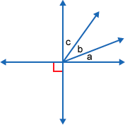

29.If https://my.westcottcourses.com/images/common/angleNOarc.gifa = x, https://my.westcottcourses.com/images/common/angleNOarc.gifb = 2x,   and   https://my.westcottcourses.com/images/common/angleNOarc.gifc = 3x,   find angles a, b, and c.

30.If https://my.westcottcourses.com/images/common/angleNOarc.gifa = 2x, https://my.westcottcourses.com/images/common/angleNOarc.gifb = 3x,   and   https://my.westcottcourses.com/images/common/angleNOarc.gifc = 4x,   find angles a, b, and c.

Use the figure below for problems #31 and #32.

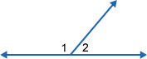

31.If https://my.westcottcourses.com/images/common/angleNOarc.gif1 = 3x + 9   and   https://my.westcottcourses.com/images/common/angleNOarc.gif2 = x - 5,   find the two angles.

32.If https://my.westcottcourses.com/images/common/angleNOarc.gif1 = 4x + 6   and   https://my.westcottcourses.com/images/common/angleNOarc.gif2 = x + 4,   find the two angles.

Find angles a, b, and c in the following figures:

33.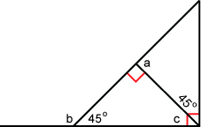

34.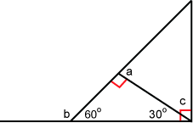

Find the following:

35.The measure of an angle is 5 less than four times the measure of the other angle.  
  
If the two angles are supplementary angles, find the measure of each angle.

36.The measure of an angle is 9 more than twice the measure of the other angle.  
  
If the two angles are supplementary angles, find the measure of each angle.

37.The measure of an angle is the square root of the measure of the other angle squared.  
  
If the two angles are supplementary angles, find the measure of each angle.

38.The measure of an angle is 4 more than the measure of the other angle.  
  
If the two angles are supplementary angles, find the measure of each angle.

39.The measure of an angle is 0 more than the measure of the other angle.  
  
If the two angles are supplementary angles, find the measure of each angle.

40.The measure of an angle is 5 more than the measure of the other angle.  
  
If the two angles are supplementary angles, find the measure of each angle.

41.The measure of an angle is 45 less than half the measure of the other angle.  
  
If the two angles are supplementary angles, find the measure of each angle.

42.The measure of an angle is 9 more than an eighth of the measure of the other angle.  
  
If the two angles are supplementary angles, find the measure of each angle.

43.The measure of an angle is the difference between 5 times the measure of the other angle and the measure of the other angle.  
  
If the two angles are supplementary angles,   find the measure of each angle.

44.The measure of the first angle is 36 more than 7 times the second angle.  
  
If the two angles are supplementary angles, find the measure of each angle.

45.The measure of an angle is 5 less than four times the measure of the other angle.  
  
If the two angles are complementary angles, find the measure of each angle.

46.The measure of an angle is 9 more than twice the measure of the other angle.  
  
If the two angles are complementary angles, find the measure of each angle.

47.The measure of an angle is the square root of the measure of the other angle squared.  
  
If the two angles are complementary angles, find the measure of each angle.

48.The measure of an angle is 4 more than the measure of the other angle.  
  
If the two angles are complementary angles, find the measure of each angle.

49.The measure of an angle is 0 more than the measure of the other angle.  
  
If the two angles are complementary angles, find the measure of each angle.

50.The measure of an angle is 5 times more than the measure of the other angle.  
  
If the two angles are complementary angles, find the measure of each angle.

51.The measure of an angle is 6 times greater than the measure of the other angle plus 1.  
  
If the two angles are complementary angles, find the measure of each angle.

52.The measure of an angle is 9 more than an eighth of the measure of the other angle.  
  
If the two angles are complementary angles, find the measure of each angle.

53.The measure of an angle is the difference between 5 times the measure of the other angle and the measure of the other angle.  
  
If the two angles are complementary angles,   find the measure of each angle.

54.The measure of an angle is 45 more than half the measure of the other angle.  
  
If the two angles are complementary angles, find the measure of each angle.

Find x:

55.  
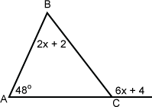

56.  
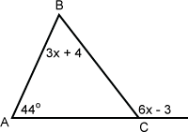

57.  
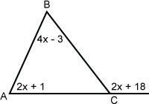

58.  
